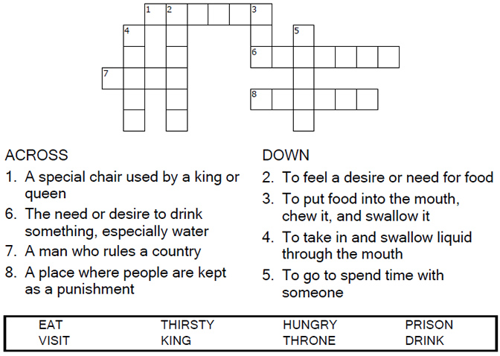

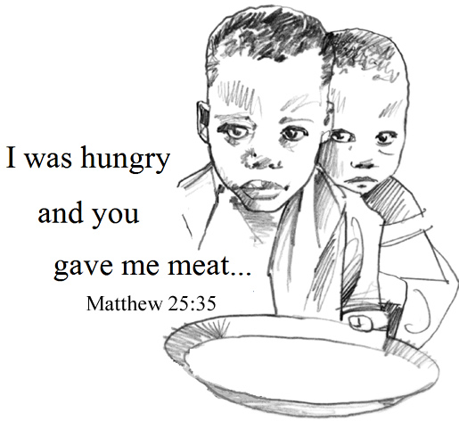
Copyright © Sermons4Kids, Inc.
May be reproduced for Ministry Use

Children’s Worship Bulletin

Unto the Least of these

Matthew 25:31-46

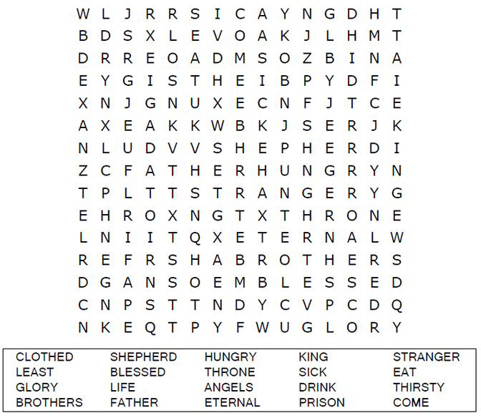
Faith United Methodist Church

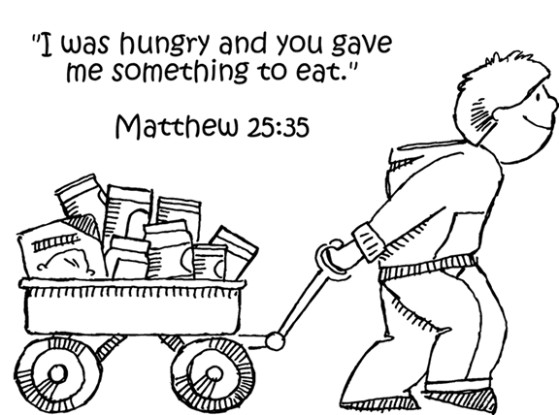

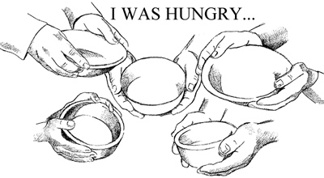

Copyright © CalvaryCurriculm.com
Used by Permission

Choose the answer that best matches the definition.

